MVC Pattern stands for Model-View-Controller Pattern. This pattern is used to separate application's concerns.

* **Model** - Model represents an object or JAVA POJO carrying data. It can also have logic to update controller if its data changes.
* **View** - View represents the visualization of the data that model contains.
* **Controller** - Controller acts on both model and view. It controls the data flow into model object and updates the view whenever data changes. It keeps view and model separate.

Implementation

We are going to create a *Student* object acting as a model.*StudentView* will be a view class which can print student details on console and *StudentController* is the controller class responsible to store data in *Student* object and update view *StudentView* accordingly.

*MVCPatternDemo*, our demo class, will use *StudentController* to demonstrate use of MVC pattern.

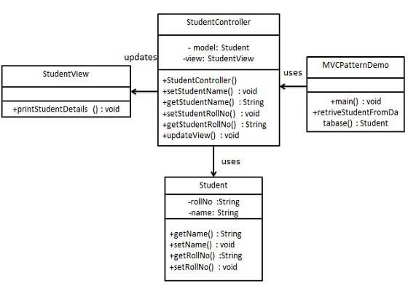

Step 1

Create Model.

*Student.java*

public class Student {

private String rollNo;

private String name;

public String getRollNo() {

return rollNo;

}

public void setRollNo(String rollNo) {

this.rollNo = rollNo;

}

public String getName() {

return name;

}

public void setName(String name) {

this.name = name;

}

}

Step 2

Create View.

*StudentView.java*

public class StudentView {

public void printStudentDetails(String studentName, String studentRollNo){

System.out.println("Student: ");

System.out.println("Name: " + studentName);

System.out.println("Roll No: " + studentRollNo);

}

}

Step 3

Create Controller.

*StudentController.java*

public class StudentController {

private Student model;

private StudentView view;

public StudentController(Student model, StudentView view){

this.model = model;

this.view = view;

}

public void setStudentName(String name){

model.setName(name);

}

public String getStudentName(){

return model.getName();

}

public void setStudentRollNo(String rollNo){

model.setRollNo(rollNo);

}

public String getStudentRollNo(){

return model.getRollNo();

}

public void updateView(){

view.printStudentDetails(model.getName(), model.getRollNo());

}

}

Step 4

Use the *StudentController* methods to demonstrate MVC design pattern usage.

*MVCPatternDemo.java*

public class MVCPatternDemo {

public static void main(String[] args) {

//fetch student record based on his roll no from the database

Student model = retriveStudentFromDatabase();

//Create a view : to write student details on console

StudentView view = new StudentView();

StudentController controller = new StudentController(model, view);

controller.updateView();

//update model data

controller.setStudentName("John");

controller.updateView();

}

private static Student retriveStudentFromDatabase(){

Student student = new Student();

student.setName("Robert");

student.setRollNo("10");

return student;

}

}

Step 5

Verify the output.

Student:

Name: Robert

Roll No: 10

Student:

Name: John

Roll No: 10